**Spring Board 작성하기**

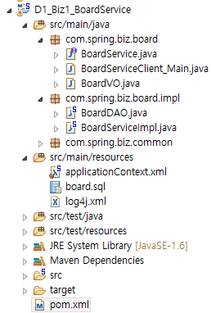

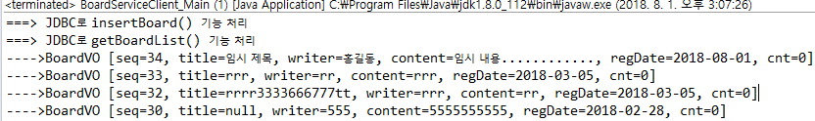

|  |
| --- |
| **CREATE** **TABLE** BOARD(  SEQ NUMBER(5) **PRIMARY** **KEY**,  TITLE VARCHAR2(200),  WRITER VARCHAR2(20),  CONTENT VARCHAR2(2000),  REGDATE **DATE** **DEFAULT** SYSDATE,  CNT NUMBER(5) **DEFAULT** 0  );  **INSERT** **INTO** BOARD(SEQ, TITLE, WRITER, CONTENT) **VALUES**(1, '가입인사', '관리자', '잘부탁 드립니다....'); |

|  |
| --- |
| **import** java.util.Date;  // VO(Value Object)  **public** **class** BoardVO {    **private** **int** seq;  **private** String title;  **private** String writer;  **private** String content;  **private** Date regDate;  **private** **int** cnt;    **public** **int** getSeq() {  **return** seq;  }  **public** **void** setSeq(**int** seq) {  **this**.seq = seq;  }  **public** String getTitle() {  **return** title;  }  **public** **void** setTitle(String title) {  **this**.title = title;  }  **public** String getWriter() {  **return** writer;  }  **public** **void** setWriter(String writer) {  **this**.writer = writer;  }  **public** String getContent() {  **return** content;  }  **public** **void** setContent(String content) {  **this**.content = content;  }  **public** Date getRegDate() {  **return** regDate;  }  **public** **void** setRegDate(Date regDate) {  **this**.regDate = regDate;  }  **public** **int** getCnt() {  **return** cnt;  }  **public** **void** setCnt(**int** cnt) {  **this**.cnt = cnt;  }  } |

|  |
| --- |
| **import** java.sql.Connection;  **import** java.sql.DriverManager;  **import** java.sql.PreparedStatement;  **import** java.sql.ResultSet;  **public** **class** JDBCUtil {  **public** **static** Connection getConnection() {  **try** {  Class.*forName*("org.h2.Driver");  **return** DriverManager.*getConnection*("jdbc:h2:tcp://localhost/~/test", "sa", "");  } **catch** (Exception e) {  e.printStackTrace();  }  **return** **null**;  }  **public** **static** **void** close(PreparedStatement stmt, Connection conn) {  **if**(stmt != **null**) {  **try** {  **if**(!stmt.isClosed()) stmt.close();  } **catch** (Exception e) {  e.printStackTrace();  } **finally** {  stmt = **null**;  }  }    **if**(conn != **null**) {  **try** {  **if**(!conn.isClosed()) conn.close();  } **catch** (Exception e) {  e.printStackTrace();  } **finally** {  conn = **null**;  }  }  }    **public** **static** **void** close(ResultSet rs, PreparedStatement stmt, Connection conn) {  **if**(rs != **null**) {  **try** {  **if**(!rs.isClosed()) rs.close();  } **catch** (Exception e) {  e.printStackTrace();  } **finally** {  rs = **null**;  }  }    **if**(stmt != **null**) {  **try** {  **if**(!stmt.isClosed()) stmt.close();  } **catch** (Exception e) {  e.printStackTrace();  } **finally** {  stmt = **null**;  }  }    **if**(conn != **null**) {  **try** {  **if**(!conn.isClosed()) conn.close();  } **catch** (Exception e) {  e.printStackTrace();  } **finally** {  conn = **null**;  }  }  }  } |

|  |
| --- |
| **import** java.sql.Connection;  **import** java.sql.PreparedStatement;  **import** java.sql.ResultSet;  **import** java.util.ArrayList;  **import** java.util.List;  **import** org.springframework.stereotype.Repository;  **import** com.spring.biz.board.BoardVO;  **import** com.spring.biz.common.JDBCUtil;  **public** **class** BoardDAO {  // JDBC 관련 변수  **private** Connection conn = **null**;  **private** PreparedStatement stmt = **null**;  **private** ResultSet rs = **null**;    // SQL 명령어들    // CRUD 기능의 메소드 구현  // 글 등록  **public** **void** insertBoard(BoardVO vo){  }    // 글 수정  **public** **void** updateBoard(BoardVO vo){    }    // 글 삭제  **public** **void** deleteBoard(BoardVO vo){    }    // 글 상세 조회  **public** BoardVO getBoard(BoardVO vo){  }    // 글 목록 조회  **public** List<BoardVO> getBoardList(BoardVO vo){  } |

|  |
| --- |
| **import** java.util.List;  **public** **interface** BoardService {  // CRUD 기능의 메소드 구현  // 글 등록  **void** insertBoard(BoardVO vo);  // 글 수정  **void** updateBoard(BoardVO vo);  // 글 삭제  **void** deleteBoard(BoardVO vo);  // 글 상세 조회  BoardVO getBoard(BoardVO vo);  // 글 목록 조회  List<BoardVO> getBoardList(BoardVO vo);  } |

|  |
| --- |
| **import** java.util.List;  **import** org.springframework.beans.factory.annotation.Autowired;  **import** org.springframework.stereotype.Service;  **import** com.spring.biz.board.BoardService;  **import** com.spring.biz.board.BoardVO;  **public** **class** BoardServiceImpl **implements** BoardService {    } |

|  |
| --- |
| <?xml version=*"1.0"* encoding=*"UTF-8"*?>  <beans xmlns=*"http://www.springframework.org/schema/beans"*  xmlns:xsi=*"http://www.w3.org/2001/XMLSchema-instance"*  xmlns:context=*"http://www.springframework.org/schema/context"*  xmlns:p=*"http://www.springframework.org/schema/p"*  xsi:schemaLocation=*"http://www.springframework.org/schema/beans http://www.springframework.org/schema/beans/spring-beans.xsd*  *http://www.springframework.org/schema/context http://www.springframework.org/schema/context/spring-context-4.2.xsd"*>        </beans> |

|  |
| --- |
| **import** java.util.List;  **import** org.springframework.context.support.AbstractApplicationContext;  **import** org.springframework.context.support.GenericXmlApplicationContext;  **public** **class** BoardServiceClient_Main {  **public** **static** **void** main(String[] args) {    BoardVO vo = **new** BoardVO();  vo.setTitle("임시 제목");  vo.setWriter("홍길동");  vo.setContent("임시 내용............");  boardService.insertBoard(vo);    //글목록 검색 기능 테스트    container.close();  }  } |